Eliza Broadus Offering
For Office Use Only
Date received
Date emailed
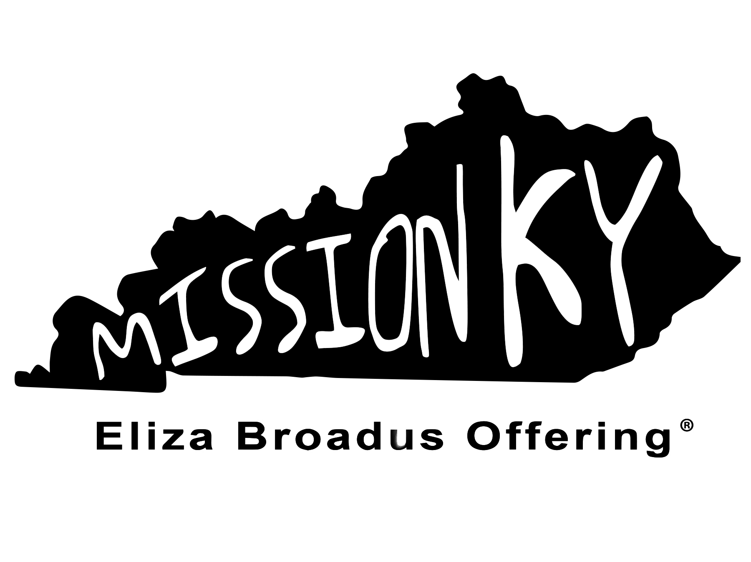
Special Ministry
Allocation Request
Applications are received between September 1 and December 15
Before completing this application, please review the instructions* and note the following:
The Eliza Broadus Offering is a state missions offering in support of Kentucky Baptist mission work. The offering is sponsored by Kentucky WMU in partnership with the Kentucky Baptist Convention. Only ministries affiliated with the KBC, a Kentucky Baptist association, or a KBC church may apply. It is an expectation that the home church of those who apply for EBO grants participate in the offering.
Please respond to each of the following:
Name of Kentucky Baptist Association in which this ministry is located:
Name of person submitting this application: (Person submitting application must be a member of a Kentucky Baptist Convention Church)
Applicant’s Church: Association:

Does your church contribute to the Cooperative Program through the KBC? Yes No
Does your church contribute to the Eliza Broadus Offering? Yes No
Amount given by your church to EBO last year: $
Contact Information for the Ministry
Name of Organization:
Name of Person responsible for ministry supervision:
Address:
City, State, Zip:
Telephone number(s):
Email address:
Website:
The ministry must be affiliated with at least one of the following: Please check appropriate box(es)/explain affiliation.
Kentucky Baptist Convention:
KBC Affiliated Baptist Association:
KBC Affiliated Church:
Ministries that are not affiliated to one of the above are not eligible for consideration.
EBO GRANT Amount requested: $
EBO grant check made payable to:
(Checks must be made payable to the ministry, church, or association)
Federal Tax Identification Number for this Ministry:
Check is to be mailed: Organization address above or
Other – Name:
Street Address, City, State, Zip:
Please continue the grant request on the back.
Share about the ministry including the following: ministry objective(s), persons to be reached, and how will an EBO grant help you reach people who do not know Christ as Savior and Lord and are currently not affiliated with any church: (use an additional sheet if necessary)

How is the ministry funded? And what are the expenses of this ministry? How do you plan to use the grant within the ministry?
(A budget for the ministry AND for the organization which will receive the check is required with the application.)

An ENDORSEMENT IS REQUIRED from either the Association Missions Strategist (or Moderator) OR the Association WMU Director in which the ministry resides.

Please check: Endorsement provided by:
Association Mission Strategist or Moderator
Association WMU Director
Please indicate why you endorse this ministry. Use an additional sheet if necessary.

Signature:____________________________________________________ Date: ________________________

APPLICANT CHECKLIST:
Budget for the ministry
Budget for the organization which will receive the check (applications without budgets will not be considered)
Accountability Form (if not a first time application) or
First time application

Please return this form and applicable materials to:
Eliza Broadus Offering Allocation Request
Kentucky WMU
13420 Eastpoint Centre Drive
Louisville, KY 40223

*REVISED Instructions are available online: www.kywmu.org/eboapplication.
EBO Grant Application – Revised 2021

