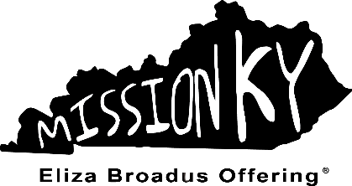
Eliza Broadus Offering Association
GRANT REQUEST
& ACCOUNTABILITY FORM
KENTUCKY WOMAN’S MISSIONARY UNION
Philosophy Statement
The Eliza Broadus Offering Philosophy Statement shall be followed in all
situations involving the Eliza Broadus Offering Funds.

Funds from the offering will be used for ministry/evangelism in Kentucky with persons beyond the in-fellowship work of local churches (specifically with those who are not currently members of any church) or for ministries/events which will provide training or support for ministry/evangelism in Kentucky with persons beyond the in-fellowship work of local churches.

Adopted April 2013 by Kentucky WMU Executive Board

Dates and Information
- This form/ accountability report is created for Kentucky Baptist Associations/Networks
- This form must be completed and postmarked by December 15 or at conclusion of the project (if the conclusion is prior to December 15), whichever is first. A completed accountability report is required for consideration for future EBO grants.
- January 2022, the Finance Committee meets to review and approve the 2023-2024 EBO funding requests during their Executive Board Winter Session.
- Each AMS/NMS is responsible for filling out this Grant Request/Accountability Report for their Association/Network. If role is vacant, please sent to appropriate representative.
- Both Grant Request and Accountability forms must be completed for an association to receive subsequent allocations. Please keep a copy of the completed form/report for your records.
- Promote and speak on behalf of the Eliza Broadus Offering for Kentucky Missions® at churches and associational meetings throughout the year.
- Include on all printed, website, and promotional material the following statement:
Made possible by your gifts to the Eliza Broadus Offering® for Kentucky Missions
Eliza Broadus Offering Association

GRANT REQUEST

Association: Click or tap here to enter text. Name of AMS: Click or tap here to enter text.
Mailing Address: Click or tap here to enter text.
Phone Number: Click or tap here to enter text.
Email Address: Click or tap here to enter text.

____________________________________________________________

YES, Click or tap here to enter text. Association would like to apply for a $500 grant from the 2023-2024 Eliza Broadus Offering for State Missions.

NO grant requested.

Should the check be mailed to the address listed above? yes no

If no, please provide name and address where the association check should be mailed.
Click or tap here to enter text.

____________________________________________________________

Please Note: If we do not receive this grant request, it is understood that no grant will be requested. If you are having problems sending your form due to unforeseen circumstances/natural disaster, please call our office immediately for an extension. If there was intention to send form or if you missed the deadline, the Finance Committee of Kentucky WMU will determine if additional funds will be distributed after the close of the offering year (August 31) and following the completion of the annual audit.
____________________________________________________________

I have read the information and understand the purpose of the Eliza Broadus Offering® for Kentucky Missions.

As an EBO recipient, I will …
- include on all printed and promotional material the following statement:
Made possible by your gifts to the Eliza Broadus Offering® for Kentucky Missions
- submit throughout the year to Kentucky WMU, stories of lives changed because of this ministry.
- SOCIAL MEDIA – use #EBO[includeyear] when posting about an event sponsored by EBO.

Name of person submitting request: Click or tap here to enter text.
Title: Click or tap here to enter text.
Signature: ____________________________

ACCOUNTABILITY FORM
2021-2022 Eliza Broadus Offering Grant Amount Received: $ 500

Provide an overview of how the funds were used by completing the following.
Name of Ministry OR Project: Click or tap here to enter text.
Ministry Project/Event Supervisor: Click or tap here to enter text.
Type of Project On-going One-time

How was this grant money used to accomplish your ministry goal?
Click or tap here to enter text.

Tell the story of a person impacted by this ministry grant:
Click or tap here to enter text.

Share how this ministry furthers missions/evangelism in your association:
Click or tap here to enter text.

Share how many people were impacted by this ministry effort and if any salvations were recorded:
Click or tap here to enter text.

Share a “Because You Give” statement and encourage Kentucky Baptists to give to EBO:
Click or tap here to enter text.

AMS Signature: ______________________________ Date: _____________________

Please keep a copy for your record

Mail to: Kentucky Woman’s Missionary Union
13420 Eastpoint Centre Drive
Louisville, KY 40223

OR email to: denise.gardner@kybaptist.org

For additional questions or to confirm receipt of your request,
call Denise Gardner at 502-489-3427.

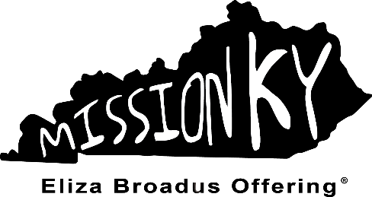

13420 Eastpoint Centre Drive | Louisville, KY 40223 | 502-489-3534 | kywmu.org

