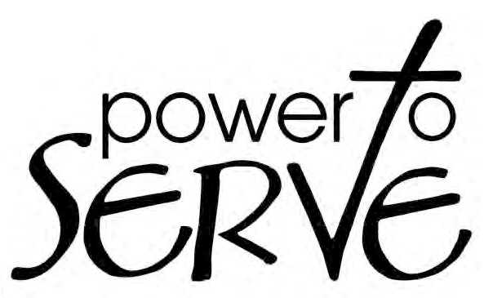
2014 State Mission Study

Date: _________________

Time: _________________

Location: ______________

Learn how God provides the power to serve and share the gospel!

“But you will receive power when the Holy Spirit has come on you, and you will be My witnesses in Jerusalem, in all Judea and Samaria, and to the ends of the earth.”
2014 State Mission Study

Date: _________________

Time: _________________

Location: ______________

Learn how God provides the power to serve and share the gospel!

“But you will receive power when the Holy Spirit has come on you, and you will be My witnesses in Jerusalem, in all Judea and Samaria, and to the ends of the earth.”

