Eliza Broadus Offering
For Office Use Only
Date received
Date emailed
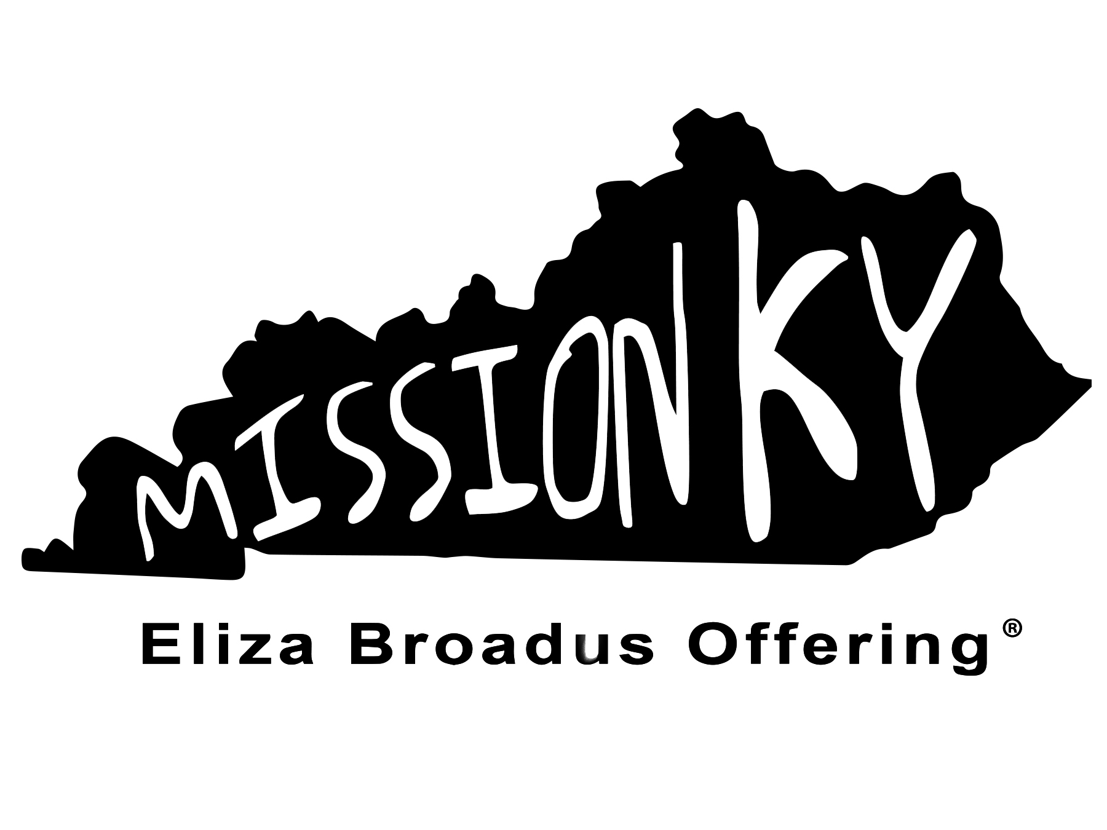
Special Ministry
Allocation Request
Philosophy Statement
The Eliza Broadus Offering Philosophy Statement shall be followed in all
situations involving the Eliza Broadus Offering Funds.

Funds from the offering will be used for ministry/evangelism in Kentucky with persons beyond the in-fellowship work of local churches (specifically with those who are not currently members of any church) or for ministries/events which will provide training or support for ministry/evangelism in Kentucky with persons beyond the in-fellowship work of local churches.

Adopted April 2013 by Kentucky WMU Executive Board
Application Instructions and Dates
• This grant request is for Special Ministries that are affiliated with at least one of the following: (1) Kentucky Baptist Convention (KBC), (2) local Baptist Association/Network affiliated with the KBC, or (3) a KBC affiliated church.
• The grant application process opens September 1 and concludes December 15. This application must be completed and postmarked by December 15. Late applications are disqualified.
• January 2022, the Finance Committee meets to review and approve the 2023-2024 EBO funding requests during their Executive Board Winter Session and will award by April.
• Returning applicants must complete an accountability form for consideration for subsequent Special Ministry EBO grants.
• Priority will be given to funding requests for ministry expenses such as literature, Bibles, tracts, and other supplies for ministry/evangelism beyond the in-fellowship work of local churches. EBO Grants can not be applied to salaries, regular bills, or building expenses including maintenance.
• Priority will be given to Special Ministries whose sponsor church is affiliated with the Kentucky Baptist Convention and gives to the Eliza Broadus Offering and Cooperative Program. Check with the church’s financial secretary to include giving information.
• Each applicant is responsible for securing an endorsement statement and signature from the AMS/NMS or Associational WMU Director for your local association/network area.
• When filling this application, please include a detailed description of how the money will be used for your special ministry/project/event. Avoid vague language.
• Familiarize yourself with the work of Kentucky WMU and the Eliza Broadus Offering. Speak on behalf of the Eliza Broadus Offering for Kentucky Missions® at churches and associational meetings throughout the year.
• Include on all printed, website, and promotional material the following statement:
Made possible by your gifts to the Eliza Broadus Offering® for Kentucky Missions

SPECIAL MINISTRIES ALLOCATION REQUEST
Please respond to each of the following

Name of Kentucky Baptist Association in which this ministry is located:
Name of person submitting this application: (Person submitting application must be a member of the sponsoring Kentucky Baptist Convention Church)
Sponsoring Church: Association:

Does your church contribute to the Cooperative Program through the KBC? Yes No
Does your church contribute to the Eliza Broadus Offering? Yes No
Amount given by your church to EBO last year: $
Contact Information for the Ministry
Name of Organization:
Name of Person responsible for ministry supervision:
Address:
City, State, Zip:
Telephone number(s):
Email address:
Website:

The ministry must be affiliated with at least one of the following: Please check appropriate box(es)/explain affiliation.
Kentucky Baptist Convention:
KBC Affiliated Baptist Association:
KBC Affiliated Church:
Ministries that are not affiliated to one of the above are not eligible for consideration.
EBO GRANT Amount requested: $
EBO grant check made payable to:
(Checks must be made payable to the ministry, church, or association)
Federal Tax Identification Number for this Ministry:

Check is to be mailed: Organization address above or
Other – Name:
Street Address, City, State, Zip:

Please continue the grant request on the back.
SPECIAL MINISTRY PURPOSE AND GOALS (use additional page if needed)
What is your ministry objective?
Click or tap here to enter text.

Share about the persons you are reaching and how the EBO grant will help you reach these people for the gospel?
Click or tap here to enter text.

Share how this ministry furthers missions/evangelism in your association:
Click or tap here to enter text.

Share how many people are impacted by this ministry effort and if any salvations were recorded this year:
Click or tap here to enter text.

Apart from the EBO Grant, how will this ministry be funded and what expenses do you incur annually? (Please include a budget for this ministry AND for the organization which will receive the check; these items are required with the application.)
Click or tap here to enter text.

An ENDORSEMENT IS REQUIRED from either the Association Missions Strategist (or Moderator) OR the Association WMU Director in which the ministry resides. Applicants can not endorse their own application.

Please check: Endorsement provided by:
Association Mission Strategist or Moderator
Association WMU Director
Please indicate why you endorse this ministry. Use an additional sheet if necessary.

Signature:____________________________________________________ Date: ________________________

SUBMITTING YOUR APPLICATION

Before you submit your application, please make sure you have the following items included with your application.

APPLICANT CHECKLIST:
Using current REVISED application (must have current year in footer)
Budget for the ministry
Budget for the organization which will receive the check (applications without budgets will not be considered)
Accountability Form (if not a first-time application) or
First time application
Financial Giving information for EBO and CP from Sponsor Church
Endorsement from Association Missions Strategist or Association WMU Director

Please return this form and applicable materials to:
Kentucky WMU
ATTN: EBO Special Ministries Allocation Request
13420 Eastpoint Centre Drive
Louisville, KY 40223

To confirm receipt of your application, please contact Denise Gardner at 502.489.3427 or denise.gardner@kybaptist.org.

