The work of WMU is designed to challenge believers on a personal level so that we can pray, learn, give, and serve with missions urgency. Take a moment and rate each statement from one to five. (1-rarely; 2- sometimes; 3-usually; 4-most times; 5-always)

- _____ I desire to understand the nature, implications, and evidence of God’s missionary purpose and to respond in personal commitment and obedience.

- _____ I use the missionary birthday prayer calendar to pray for missionaries.

- _____ I attend WMU events held in my state.

- _____ I am intentional about helping my church engage in missions whether or not they have all the WMU groups.

- _____ I pray for missions efforts being done in my church, our missions entities, and our missions partners both locally and globally.

- _____ I pray for people who have not yet been reached with the gospel as well as situations where people are not open to missionary personnel.

- _____ I am purposeful in creating relationships with non-believers.

- _____ I view my neighborhood as my mission field and make it a point to engage people with the gospel.

- _____ I am actively finding ways where I can serve in missions, whether on a mission trip or in my hometown.

- _____ I am actively discipling at least one person.

- _____ I sacrificially give to missions offerings in my church.

- _____ I work to create an environment in my church for people to hear and respond to God’s call to mission service.

- _____ I purchase items and create packages for things like operational Christmas child, Christmas in August, or the Christmas backpacks.

- _____ I make it a personal priority to “adopt and care” for missionaries by encouraging them through email, postal mail, and finding creative ways to support their work.

- _____ I work on developing my cultural skills in order to reach people in their context.

- _____ I work with my pastor to help others know the importance of giving to missions.

- _____ My missions group keeps me accountable for sharing the gospel and living out the Great Commission.

- _____ I understand the power of prayer and seek to engage others in various prayer opportunities.

- _____ I view the missions stories as examples and look for ways I can reach people where I live with the ideas I’ve learned.

- _____ I take prayer seriously and frequently pray as an intercessor for others.

SCORING YOUR ASSESSMENT
Input your scores to the coordinating statement, then tally your score.
P | L | G | S
2. ______ | 1. ______ | 11. ______ | 4. ______
5. ______ | 3. ______ | 12. ______ | 7. ______
6. ______ | 15. _____ | 13. ______ | 8. ______
18. _____ | 17. _____ | 14. ______ | 9. _____
20. _____ | 19. _____ | 16. ______ | 10. _____
Total: ______ | Total: ______ | Total: ______ | Total: ______

Plot your scores for each area on the chart below.

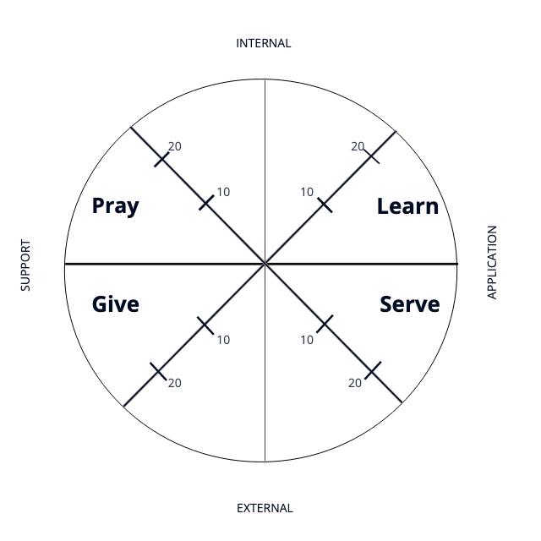

WMU in the Church

As you engage in missions through WMU in your church, your participation should reflect four characteristics of a missional person. These characteristics reflect biblical understanding about missions and help to make disciples who
- Learn about missions;
- Pray for missions;
- Give missions; and
- Serve in missions.

These characteristics provide a comprehensive and holistic approach to missions discipleship. They relate to and complement each other. While all the characteristics help a church fulfill its mission, the beginning of an individual’s participation in WMU or the beginning of WMU in a church may be with only one characteristic. The goal is to engage in all focus areas.
Learn about missions intentionally involves people in experiences that increase their awareness and knowledge of missions. These learning experiences help people develop understandings, appreciations, attitudes, and skills for doing, telling, supporting, and praying for missions. People are also led to explore with growing understanding the nature, implications, and evidences of God’s missionary purpose and to respond to that purpose in personal commitment and obedience.
Missions is the work of God through the church by which the gospel of Jesus Christ is extended in word and deed to all the people in the world.
What does this this mean for me: As a disciple of Jesus, I learn what the Bible says about missions and my role making disciples. I also learn from missionaries “on the field”. As I hear from missionaries and read their stories, I am challenged to personally get involved in missions.
What does this mean for my church: As member of my church, I encourage, support and engage with hands-on missions involvement. I also encourage cooperative missions with other churches in my association, state convention, and national and international missions entities.

Pray for missions is communication with God on behalf of missions work; the people involved in doing it; and the people who need to know and accept God’s redeeming love. As you strengthen your missions prayer life, you will begin to see that missionaries and the lost will inhabit your prayers daily. Prayer for missions may also include praying for Christian believers in places where there are few believers and where cultural differences make it difficult to effectively communicate the gospel.
What does this this mean for me: Participating in missions through prayer, means that you desire to understand biblical principles and concepts of prayer as well as knowledge of missions activities and needs. You understand that prayer is essential for people who live on mission. By recognizing that divine resources are essential for effective missions work, you pray for boldness and opportunities for sharing the Gospel.
What does this mean for my church: As member of your church, you uphold missions efforts with prayer includes praying for missions work being done by my church, missions entities to which your church relates, and missions partners both locally and globally. You champion praying for missions; including praying for people who have not yet been reached with the gospel as well as situations that may not be open to missions personnel and established missions work.

Give to/support in missions means to promote an interest in the cause of missions and those involved in missions in order to fulfill the mission of God. Through this characteristic, people show concern for others by supporting missionaries, missions partners, and missions work through their giving and encouragement. Also, people support missions through emphasizing the need for individuals to become involved in mission service and nurturing those whom God calls to mission service. Supporting missions is a practical way for a church to participate in missions.
What does this this mean for me: As a supporter of missions, I understand that support means that giving of our time, talent, and treasure. Providing financial support, furnishing personal ministries for missionaries and their families, creating an environment for people to hear and respond to God’s call to mission service, and nurturing individuals who respond to missions service becomes as priority as I develop a passion for missions involvement.
What does this mean for my church: WE champion sacrificial giving to send others to reach the nations and seek to care well for those on the field. We develop opportunities for our church to care for, learn about, and serve missionaries. We recognize the need for missions personnel and encourage those that God may be calling to mission service.

Serve in missions means that the teachings and actions of Jesus show that the Christian faith is not stagnant but active and participatory. Serve in missions encompasses both doing missions and telling about Jesus. Living on mission is doing redemptive, loving service for people of special need or circumstance in the name and spirit of Christ and sharing the gospel with them. Doing missions is also responding to social and moral issues. To tell about Jesus is to share the gospel of Jesus Christ with another person and give that person an opportunity to confess Jesus Christ as Savior and Lord.
What does this this mean for me: I must learn to share the gospel in word and deed through missions projects that relate to what they are learning. Disciples understand that “living on mission” means actively engaging in missions each day. You understand that meeting a person’s needs in Christ’s name calls for positive and personal action, ultimately looking for opportunities to engage in gospel conversation.
What does this mean for my church: It means that you are actively engaged with helping your church participate in hands-on missions and evangelism. You encourage your church to work together, combine resources, and respond to needs/lostness in your community, state, nation, and around the world.

How can I strengthen all areas of missions engagement? (write your ideas here)

PRAY for missions | LEARN about missions
GIVE to/support missions | SERVE in missions

